2019 Association for Counselor Education & Supervision
National Conference

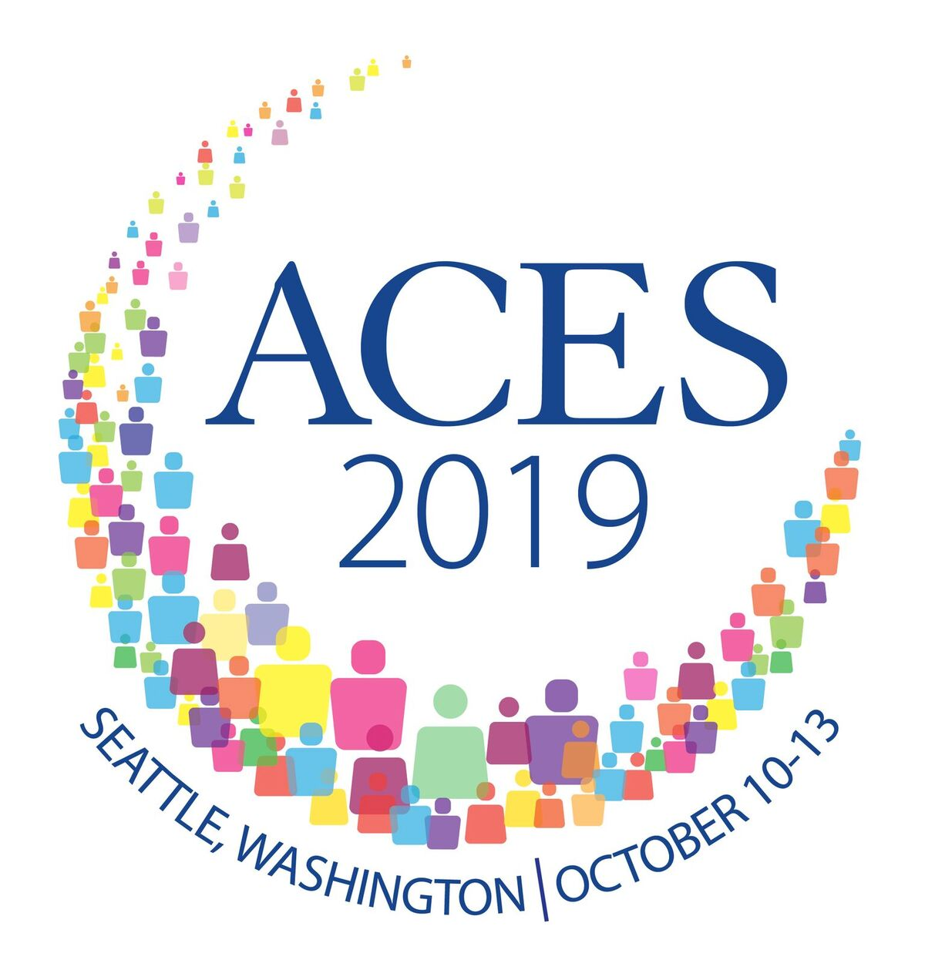

Sheraton Seattle
October 10th - October 13^{th,} 2019

Exhibiting and Sponsorship Opportunities

We hope you will join us as a sponsor or exhibitor at this year's most exciting conference! Almost 2,000 counselors, counselor educators, counselor supervisors, and students will attend the Association for Counselor Education & Supervision (ACES) conference. With numerous receptions, general sessions, and breaks scheduled at the conference, you will have multiple opportunities to interact with conference attendees and promote your business or school.

Location and Accommodations

The conference will be held at the Sheraton, Seattle. ACES has a reserved block of rooms at a special room rate ($224.00 + tax) for standard king or queen. Reserve rooms online through the ACES conference website reservation link.

Almost 2,000 Counselors, Counselor Educators, Supervisors, and Students are Expected to Attend!

Registration

To register as a sponsor or exhibitor, please click on the following link for registration through Cvent: http://bit.ly/ACES2019Conference

Space is limited so please register early. Booth placement will be decided on a first come, first serve basis.

Why Exhibit? Benefits Include:

Exhibiting at the 2019 ACES National Conference in fantastic Seattle is a great way to increase your visibility at the only national conference specifically for professional counselor educators and supervisors.

● Sell/introduce new products ● Expand sales
● Generate referrals ● Build service or product credibility
● Give demonstrations ● Meet customers face-to-face
● Recruit new authors ● Generate brand recognition
● Reach new markets ● Increase visibility

ACES Expo Express Hours

Thursday, October 10th -1:00pm - 6:00pm

Friday, October 11th - 8:00am - 6:00pm

Saturday, October 12^{th -} 8:00am - 4:00pm

Benefits for Exhibitors

- Business listing and description on the ACES conference website and in the conference program
- Steady traffic flow of qualified buyers, prospective collaborators, and recommenders
- Consistent and frequent access to conference attendees
- Promotional opportunities
- List your business, association, or educational website information on the ACES conference website (for some packages).
Expo Express Installation and Dismantling

Exhibitors will be able to set up between 10:00 am and 1:00 pm on Thursday, October 10th, 2019. Dismantling will begin at 4:00 pm on Saturday, October 12th and should be completed by 8:00 pm that same day.

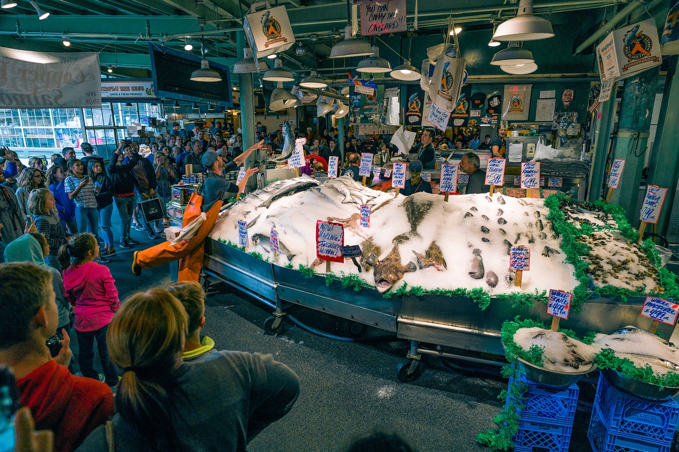

Exhibitor Service Information

Exhibitor services will be provided by Triumph Events & Expo. Inc. Items such as additional draping, accessories, electricity, telephone, internet connections, audiovisual equipment, and drayage will be arranged through Triumph for additional charges. Exhibitors will be receiving comprehensive information packets from Triumph no later than 60 days prior to the conference.

Exhibitor Contact Information

For additional information, please contact Dr. Diane O’Brien at doctordiane06@gmail.com
or Dr. Elizabeth Villares at evillare@fau.edu
Exhibit Package Options

Package #1 - Professional Double Booth (Conference Attendance) - $1,450
- 10 x 20 booth with two (2) draped tables, four (4) chairs, trash can
- Two complimentary conference registrations (valued at approximately $670.00
- Name badge and exhibitor ribbon for two complimentary conference attendees
- Listing in the exhibitor section of the conference app and printed conference program two (2) complimentary printed program
- Listing on the ACES Virtual Expo Express at www.aces2019.net
Package #2 - Professional Single Booth (Conference Attendance) - $925
- 10 x 10 booth with draped table, two (2) chairs, trash can
- Two complimentary conference registrations (valued at approximately $670.00)
- Name badge and exhibitor ribbon for two complimentary conference attendees
- Listing in the exhibitor section of the conference app and printed conference program two (2) complimentary printed programs)
- Listing on the ACES Virtual Expo Express at www.aces2019.net
Package #3 - Professional (Exhibit Only) - $675
- 10 x 10 booth with draped table, two (2) chairs, trash can
- Listing in the exhibitor section of the conference app and printed conference program (two (2) complimentary printed programs)
- Listing on the ACES Virtual Expo Express at www.aces2019.net

Package #4 - Non-professional - $455
- 10 x 10 booth draped table, two (2) chairs, trash can

Package #5 - Registration Packet Insert: $150
- Flyer, brochure or pamphlet will be included in each attendee registration packets; 1,800 pre-printed inserts are required.

Space is limited! Early reservations are recommended. Tables will be assigned on a first-come, first-served basis.

Sponsorship Opportunities

Sponsorship levels range from platinum to bronze, including sponsorship of the conference bags, lanyards, meal functions, and more. There is something for every marketing and promotional objective and budget.

Conference Bags: $9,000
Your business, association, or institution’s name will be on the conference bag, which will be received by every conference attendee. All attendees will receive a special carry-all to hold their conference materials. Take advantage of promoting your business, association, or institution on this conference item, which also displays the ACES conference logo. This is a unique marketing opportunity for the sponsor, as many attendees will use the bag year-round.

Additional benefits of this sponsor level:
- Your business, association, or institution’s logo printed on the OPPOSITE SIDE of the bag from the ACES conference logo
- All of the benefits of the Platinum Sponsorship (excluding app designation and ad, see below)
- Listing on the ACES Conference App as Conference Bag Sponsor
- Full-page ad on the BACK COVER of the printed conference program book (optional purchase by attendees).

Conference Wi-Fi: $8,500
Your business, association, or institution’s name will be on all informational materials related to Wi-Fi access.
Additional benefits of this sponsor level:
- Your business, association, or institution’s logo printed on the SAME SIDE of the bag as the ACES Conference logo.
- All of the benefits of the Platinum Sponsorship (excluding app designation and ad, see below)
- Full-page ad inside the printed conference program book (optional purchase by attendees).
- Co-sponsorships available at $4250 each (excludes conference bag)

Conference Lanyards: $4,500
Your business, association, or institution’s name will be on the conference lanyards, which will be received by every conference attendee.
- All of the benefits of the Platinum Sponsorship (excluding app designation and ad, see below)
- Half-page ad inside the printed conference program book (optional purchase by attendees; ad placement to be determined by ACES conference staff)

Platinum $6,250 Benefits (only 1 Platinum package available)
- Exhibit table in ACES Expo Express - 10 x 10 booth with draped table, two (2) chairs, trash can
- Unique listing as the Platinum Sponsor on the ACES conference app
- Unique listing as the Platinum Sponsor in the on-site conference registration area
- Full-page ad on the INSIDE FRONT COVER of the printed conference program book (optional purchase by attendees)
- Four (4) complimentary conference registrations (valued at approximately $1400) and four (4) printed programs
- Listing with 100-word description and business logo in the ACES Virtual Expo Express
- Listing in sponsor section of the printed conference program book
- Name badge and sponsor ribbon for all four complimentary conference attendees
- Pre-printed flyer, brochure or pamphlet included in each of the attendee registration packets; 1,800 pre-printed inserts are required (optional)

Diamond $5,750 Benefits (only 1 Diamond package available)
- Exhibit table in ACES Expo Express - 10 x 10 booth with draped table, two (2) chairs, trash can
- Unique listing as the Diamond Sponsor on the ACES conference app
- Unique listing as the Diamond Sponsor in the on-site conference registration area
- Full-page ad on the INSIDE BACK COVER of the printed conference program book (optional purchase by attendees)
- Four (4) complimentary conference registrations (valued at approximately $1400) and four (4) printed programs
- Listing with 100-word description and business logo in the ACES Virtual Expo Express
- Listing in sponsor section of the printed conference program book
- Name badge and sponsor ribbon for all four complimentary conference attendees
- Pre-printed flyer, brochure or pamphlet included in each of the attendee registration packets; 1,800 pre-printed inserts are required (optional)

Gold $5,250 Benefits (only 1 Gold package available)
- Exhibit table in ACES Expo Express - 10 x 10 booth with draped table, two (2) chairs, trash can
- Unique listing as the Gold Sponsor on the ACES conference app
- Unique listing as the Gold Sponsor in the on-site conference registration area
- Full-page ad inside the printed conference program book (optional purchase by attendees)
- Four (4) complimentary conference registrations (valued at approximately $1400) and four (4) printed programs
- Listing with 100-word description and business logo in the ACES Virtual Expo Express
- Listed in sponsor section of the printed conference program book
- Link on ACES conference website
- Name badge and sponsor ribbon for all four complimentary conference attendees
- Pre-printed flyer, brochure or pamphlet included in each of the attendee registration packets; 1,800 pre-printed inserts are required (optional)

Silver $4,250 Benefits (only 2 Silver packages available)
- Exhibit table in ACES Expo Express - 10 x 10 booth with draped table, two (2) chairs, trash can
- Unique listing as the Silver Sponsor on the ACES conference app
- Unique listing as the Silver Sponsor in the on-site conference registration area
- One-half page ad in the printed conference program book (optional purchase by attendees; ad placement to be determined by ACES conference staff)
- Two (2) complimentary conference registrations (valued at approximately $700) and two (2) printed programs
- Listing with 100-word description and business logo in the ACES Virtual Expo Express
- Listed in sponsor section of the printed conference program book
- Link on ACES conference website
- Name badge and sponsor ribbon for two complimentary conference attendees
- Pre-printed flyer, brochure or pamphlet included in each of the attendee registration packets; 1,800 pre-printed inserts are required (optional)

Bronze $3,250 Benefits (only 3 Bronze packages available)
- Exhibit table in ACES Expo Express - 10 x 10 booth with draped table, two (2) chairs, trash can
- Unique listing as the Bronze Sponsor on the ACES conference app
- Unique listing as the Bronze Sponsor in the on-site conference registration area
- One-third-page ad in the printed conference program book (optional purchase by attendees; ad placement to be determined by ACES conference staff)
- Two (2) complimentary conference registrations (valued at approximately $700) and two (2) printed programs
- Listing with 100-word description and business logo in the ACES Virtual Expo Express
- Listed in sponsor section of the printed conference program book
- Link on ACES conference website
- Name badge and sponsor ribbon for two complimentary conference attendees
- Pre-printed flyer, brochure or pamphlet included in each of the attendee registration packets; 1,800 pre-printed inserts are required (optional)

Break Sponsorship: $2,000
Each day, ACES will provide morning and afternoon breaks for attendees. With this sponsorship, your business, association or institution will be able to display a poster with your logo on the break table. In addition, you can provide other promotional materials on the table. The logo to be displayed must be provided by sponsor. Your business, association or institution will be listed on the conference app and in the sponsor section of the printed conference program book as a break sponsor.

Logo Hologram $750
- See your business, association or institution logo prominently and strategically projected during the conference.

Sponsorship Contact Information: Other sponsorship opportunities are available including possibilities for custom sponsorship. For more information, please contact Dr. Shannon Karl at Shannon.Karl@nova.edu.

EXHIBITOR/SPONSOR AGREEMENT

The organization below agrees to the terms of this agreement to contract for exhibit space and/or sponsorship opportunities offered by the 2019 ACES Conference, which will be held at the Sheraton Seattle, Washington from October 10th - October 13th. This will become a contract when countersigned by the representative of the Association for Counselor Education and Supervision (ACES). ACES must receive this form by July 31, 2019, for the exhibitor or sponsor to be guaranteed listing in conference materials. A confirmation e-mail will be sent to confirm receipt of this form. Please provide the information below, which will be listed in the 2019 ACES Conference Program:

____________________________________________________________________________________
Name of Organization
(as it will appear in the conference program, limited to 26 characters and/or spaces)

Name of Contact Person to Receive All Exhibit Information

Address City State Zip

Phone Fax

E-mail address

URL for ACES Virtual Expo Express

Please provide the names of the complimentary conference attendees below. Refer to the exhibitor and/or sponsorship packet information for the number of complimentary registrations.

1.
Name of person to receive complimentary registration E-mail address

2.
Name of person to receive complimentary registration E-mail address

3.
Name of person to receive complimentary registration E-mail address

4.
Name of person to receive complimentary registration E-mail address
Exhibitor/Sponsor's Responsibilities

Exhibitor/sponsor responsibilities include:
- Provide ACES a camera-ready logo (.eps, .bmp, .tiff or .jpeg file) for use on conference materials by July 30th, 2019.
- Provide a business description for the ACES Virtual Expo Express by July 30th, 2019. See sponsor or exhibitor package for information to be provided.
- Triumph provides services such as additional draping, accessories, electricity, telephone, internet connections, audiovisual equipment, and drayage services that are not included in the registration fee.
- Exhibitors will receive a service kit from Triumph 60-90 days prior to the conference containing information about ordering these services.
- Exhibitors may not permit any other organization to use its exhibit space.

DISCLAIMER:
ACES does not provide a list of registrants or attendee contact information as part of any exhibit or sponsorship packages.

Exhibitor/Sponsor's Relationship to ACES and the Conference

Exhibitors may not distribute material regarding products or services that compete with those of ACES, nor hold meetings or otherwise encourage absence of attendees during the official hours of the conference. In the event of cancellation or relocation of the conference due to circumstances over which ACES has no control, ACES shall have no liability or responsibility to refund any fees paid by exhibitors or sponsors. ACES reserves the right to remove from the premises any or all of the property of the exhibitor without prior notice and without hearing should the conference be canceled or relocated or should the exhibitor violate any of the conditions of this agreement. ACES undertakes no duty to exercise care, nor does it assume any responsibility, for the protection and safety of the exhibitor, its representatives or property. The exhibitor agrees to indemnify and hold ACES and its agents harmless from all such claims and from all claims or liability of any nature whatsoever arising from the activities of the exhibitor or any of his representatives or from the display or use of property of the exhibitor. Exhibitor assumes all responsibility to secure their property, materials, and display at all times. ACES reserves the right to reject any exhibitor or sponsor that does not align with the mission of ACES.

Exhibitor's Agreement

I, , the duly authorized representative of the firm named above, subscribe and agree to all terms and conditions contained in this agreement.

Exhibitor Signature Date

Contract Accepted by ACES – Representative Signature Date

Register and pay online at: http://bit.ly/ACES2019Conference

